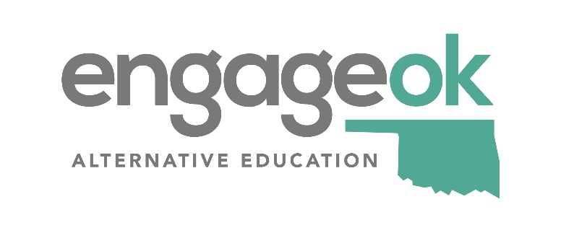
Alternative Education Middle School Evaluation Rubric

Program Name
Date of Visit:
District (LEA):
Sending Schools:
Total Points: _____ out of _____ points
Rating:
(Noncompliant: 0 points, Effective: 1 point, Highly Effective: 2 points)

Appropriate Program Design to Serve At-Risk Students | Noncompliant | Effective | Highly Effective
The program served an appropriate number of students.
Fits the description of an alternative education program that meets all 17 criteria in state statute serving students in a variety of methods.
Program allows students who otherwise met the requirements to participate in vocational programs and extra curriculum activities; included but not limited to athletics, band, and clubs.
Alternative education students were provided with standard services (ex. library access, school nutrition, transportation and facilities).
Instructional materials and staffing levels supported program quality and demonstrated a reasonable contribution of local funds beyond the state allocations.
Special education student rate matches the district special education student rate.
Student success is central to the goals and objectives of the program, which includes the development of emotional/social, intellectual, career readiness skills, and safety.
Program uses discipline as a component of the broader picture of successful student programming.
Program promotes a safe and secure environment while developing the emotional and physical wellness of all students. Program also administered a climate/culture survey to students and staff.
Notes:

Faculty Selection | Noncompliant | Effective | Highly Effective
All classes are conducted by highly qualified teachers.
Staff worked to improve their understanding of the philosophy of alternative education programming, required criteria, and instructional approaches.
Increase teacher and staff training to ensure the use of strategies that align with the needs of the program options beyond traditional professional development. (ex. regional meetings, webinars, book studies, state conferences, Ed Camps, national conferences)
Time provided for teachers collaboration and support for the development and maintenance of professional learning communities and stuffing of students.
Notes:

Intake and Screening | Noncompliant | Effective | Highly Effective
The program was appropriately designed to serve the students who were at greatest risk of not promoting to high school for reasons other than a disability.
The program ensures that all records are complete prior to enrollment in the program.
Committee (traditional, alternative education program, administration, and counselor) intake and screening were conducted with student and parent.
There is clearly defined entrance/enrollment and exit/transition process for the program that includes teachers, counselor, student, administrator and parent.
The program is accurately described as a “school of choice”.
Notes:

State and Local Collaboration | Noncompliant | Effective | Highly Effective
Coordinates services across multiple organizations to meet student needs.
Students engage in activities that provide benefit to the community.
Community-building activities are implemented to build relationships and trust between staff and students regarding commitment to learning.
Notes:

Personalized Education Plan | Noncompliant | Effective | Highly Effective
A personalized plan was completed, reviewed quarterly and included transitions to high school.
Goals for behavior factors that impeded students’ success (ex. absences, drug issues, and suspensions) were included in the plan or separate documents. (Ex. PBIS)
Rules exist that are written, clearly understood by staff, students and parents and are applied consistently to guide students behavior, monitor progress and manage the learning experience.
Notes:

Individualized Instruction | Noncompliant | Effective | Highly Effective
Individualized competency-based delivery systems are provided as well as group learning to accommodate different learning styles, speeds and abilities.
Adjustments are made in set up, delivery, and planning to better serve students’ academic, behavioral, cultural, development, gender, and social needs.
The program actively promotes student engagement and affords student with the opportunity to have a role in shaping the learning environment to facilitate feelings of connectedness.
Notes:

Effective Instruction | Noncompliant | Effective | Highly Effective
Course material meets state standards.
The program keeps up-to-date records indicating whether each student is making sufficient progress toward graduation.
Teachers and other program staff work individually with students to ensure academic success.
Uses multiple assessments to evaluate learning, instruction and interventions.
Student progress was monitored every quarter with parent contacts.
The curriculum has the appropriate rigor and is matched to the needs of learners. This could be reflected in student scores on state assessment.
The program implements Response to Intervention practices that utilizes continuous assessment for placement, instruction, intervention, and transition decisions.
Notes:

Counseling and Social Services | Noncompliant | Effective | Highly Effective
A broad range of weekly group and individual counseling services were provided that encompass academic, career, and social/emotional well-being for all students.
Social services were arranged to meet students’ academic, mental, health, and/or family needs.
Parents are offered program/school-based parents support opportunities (i.e., parent support meetings for behavior or attendance).
Notes:

Life Skills Instruction | Noncompliant | Effective | Highly Effective
The curriculum prepares students for life careers and higher levels of education.
The instructor incorporated life skills instruction and activities into regular course content and it was age appropriate and aligned to students’ interest.
Students research career fields and complete interest inventory to promote career development.
Notes:

Art Instruction | Noncompliant | Effective | Highly Effective
Arts education is infused into the curriculum and utilizes a broad spectrum of offerings (fine, performing and literary arts) in activity-based approaches.
Arts-related instructional strategies were used throughout the year to expand and to enrich the curriculum.
Students were provided with opportunities to publish or perform (ex. displays, art shows, performances, or publications on the internet). Program incorporated artists or musicians as presenters.
Notes:

Self-Evaluation | Noncompliant | Effective | Highly Effective
Program turned in a detailed expenditure report by June 30th and a proposed budget by September 15th to SDE.
Clear and measurable goals and objectives are available, posted, and discussed at least 4 times a year (state visit, presentation to the local school board, internal meeting with administration, and various internal and external evaluations).
State reporting (alternative education plan and student data) are completed by the required due dates.
Program staff use evaluative feedback, including student outcome data, for program improvement.
The program routinely reports to building and district administration, as well as, students and parents.
Program did an exit survey with students, parents, or faculty.
Notes:

